**Project Design Phase-II**

**Data Flow Diagram & User Stories**

| Date | 24 May 2023 |
| --- | --- |
| Team ID | NM2023TMID07188 |
| Project Name | Journey to Sustainability: Decoding the CO2 Impact of Travel |

**Data Flow Diagrams:**

A Data Flow Diagram (DFD) is a traditional visual representation of the information flows within a system. A neat and clear DFD can depict the right amount of the system requirement graphically. It shows how data enters and leaves the system, what changes the information, and where data is stored.

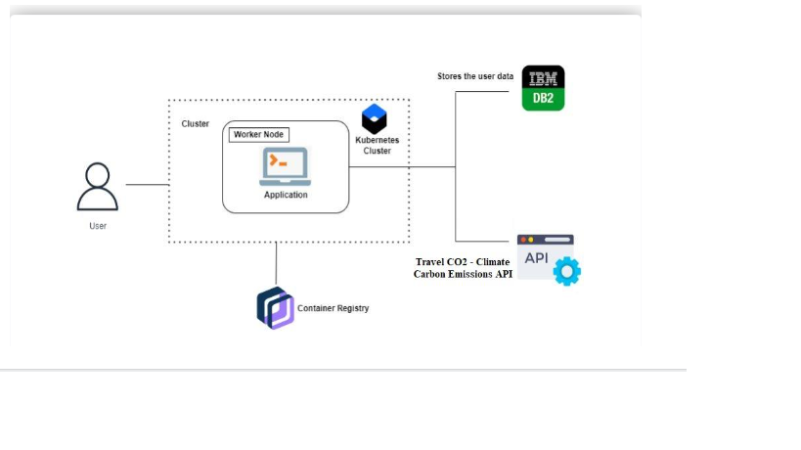

**User Stories**

Use the below template to list all the user stories for the product.

| **User Type** | **Functional Requirement (Epic)** | **User Story Number** | **User Story / Task** | **Acceptance criteria** | **Priority** | **Team Member** |
| --- | --- | --- | --- | --- | --- | --- |
| Customer (System user) | Registration | USN-1 | As a user, I can register for the application by entering my email, password, and confirming my password. | I can access my account / dashboard | High | Avinash |
|  |  | USN-2 | As a user, I will receive confirmation email once I have registered for the application | I can receive confirmation email & click confirm | High | Avinash |
|  | Login | USN-3 | As a user, I can log into the application by entering email & password |  | High | Lingesh |
|  | Dashboard |  |  |  |  |  |
| Customer (Web user) | Browse | USN-4 | As a visitor, I want to browse through a collection of places, so I can enjoy and share them with others. | 1. I can scroll through a collection of popular places.  2. I can view individual places.  3. I can easily share places on social media platforms | High | Srinath |
|  | search | USN-5 | As a user, I want to search for specific rides based on keywords or categories, so I can find places that match my interests. | I can enter keywords or select categories to search for rides. | High | Srinath |
| Admin |  | USN-6 | As a Admin , I want to curate themed places and, so I can showcase specific genres or trends to visitors. | I can add specific places to the created collections or exhibitions. | High | Imran |
|  |  |  |  |  |  |  |
|  |  |  |  |  |  |  |
|  |  |  |  |  |  |  |